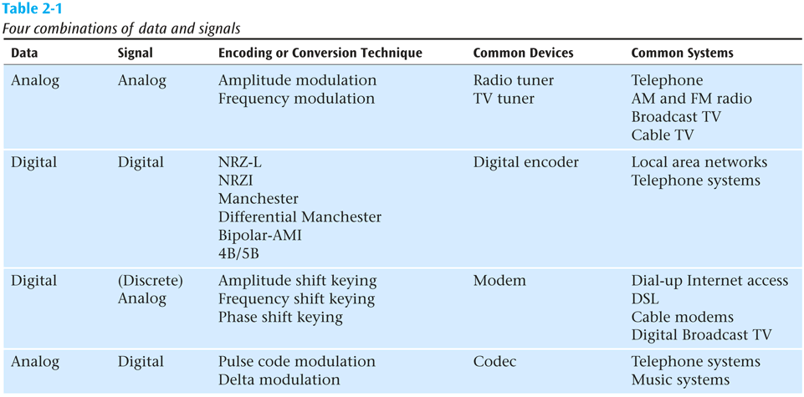

Hub

Hub is commonly used to connect segments of a LAN (Local Area Network). A hub contains multiple ports. When a packet arrives at one port, it is copied to the other ports so that all segments of the LAN can see all packets. Hub acts as a common connection point for devices in a network.

In a hub, a frame is passed along or "broadcast" to every one of its ports. It doesn't matter that the frame is only destined for one port. The hub has no way of distinguishing which port a frame should be sent to. Additionally, a 10/100Mbps hub must share its bandwidth with each and every one of its ports. In comparison, a switch keeps a record of the MAC (Media Access Control) addresses of all the devices connected to it. With this information, a network switch can identify which system is sitting on which port. So when a frame is received, it knows exactly which port to send it to, without significantly increasing network response times. In addition, unlike a hub, a 10/100Mbps switch will allocate a full 10/100Mbps to each of its ports. So regardless of the number of PCs transmitting, users will always have access to the maximum amount of bandwidth.

A Hub is a networking connector device that aids in connecting multiple devices to a single network. It is a common connection point that is also known as a network hub. It is a physical layer network device that connects a series of LANs.

Switch

A switch operates at the data link layer (layer 2) and sometimes the network layer (layer 3) of the OSI (Open Systems Interconnection) Reference Model and therefore support any packet protocol. LANs that use switches to join segments are called switched LANs or, in the case of Ethernet networks, switched Ethernet LANs. In networks, the switch is the device that filters and forwards packets between LAN segments.

Unlike an Ethernet hub or switch that is concerned with transmitting frames, a router is to route packets to other networks until that packet ultimately reaches its destination. One of the key features of a packet is that it not only contains data but the destination address of where it's going. What's more, router is the only one of these three devices that will allow you to share a single IP (Internet Protocol) address among multiple network clients.

A Switch is a networking device that has the ability to link multiple devices together on one computer network. It uses a data link layer to connect the devices. When it comes to switching, we prefer the packet switching method to dispatch the data packet over the web.

Router

A router is connected to at least two networks, commonly two LANs or WANs (Wide Area Networks) or a LAN and its ISP.s (Internet Service Provider.s) network. The router is generally located at gateways, the places where two or more networks connect. Using headers and forwarding tables, router determines the best path to forward the packets. In addition, router uses protocols such as ICMP (Internet Control Message Protocol) to communicate with each other and configures the best route between any two hosts. In a word, router forwards data packets along with networks.

A router is a device for computer networking devices that helps in connecting two or more packet-switched networks. The major role of the router is to perform the two functions. It supports in handling the traffic between the networks by dispatching data packets, and permits several devices to use the same internet connection.

